# Shreesha – Passion towards Education

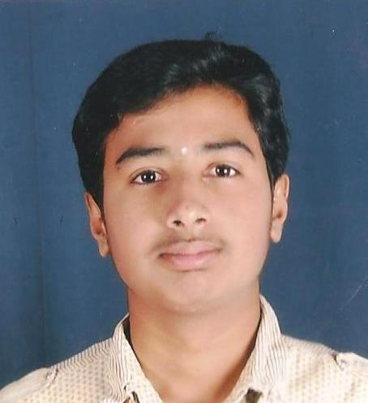Name: Shree Sha S/o Raghavendra

Date of Birth/Age: 15.12.1996, 15 years.

Class: 10thStd (English medium state syllabus)

Mother: Shashirekha.P.

Address: # 3, 18thcross,

M.T.S.Layouut,

Kangari Satalite Town,

Bangalore

I am extremely happy. I understood how difficultly my mother is supporting me. And also I am grateful to your wonderful support…..

Shree Sha is the only son of Shashirekha, father is away from the family before he is born, and Mother is the bread winner for both the son and her aged grandmother. Very recently Grand was died and now Shasirakha is taking care of him by working in a garment factory for the payment of Rs.5000pm.

With her minimum income she was able to pay rent for the house and still make him study upto 10th standard and that too in English medium, because of his excellence in studies. Every year he passed out with distinction and with well certified characters.

Now he has been sponersed you your esteem organization. In the final Govt. Exam he has passed in **excellent with 93%.** Both the mother and shreesha were extremely happy and grateful for your wonderful support.

This academic year he will be going for pre university college i.e( +1 and +2). Once he gets the college admission we will be able to give the fee structure.

Thank you

With regards.

Mr. Jayapaul.

Social worker.